**HANDSON EXERCISES - WEEK 1**

**Skill : Data Structures and Algorithms**

**Exercise 2: E-commerce Platform Search Function**

**Scenario:**

You are working on the search functionality of an e-commerce platform. The search needs to be optimized for fast performance.

**Understand Asymptotic Notation:**

Big O describes how fast or slow an algorithm is as the size of the input grows. It helps us compare which code runs faster or slower in the worst case.

* Best case (Ω) - fastest possible case in which the item we are searching for is found at the begininng itself
* Average case (θ) - general case when the item is somewhere in the middle
* Worst case (O) - Slowest case when the item is at the end or else not present at all.

**CODE :**

**Product.java :**

package com.example.Searching;

public class Product {

int productId;

String productName;

String category;

public Product(int productId, String productName, String category) {

this.productId = productId;

this.productName = productName;

this.category = category;

}

@Override

public String toString() {

return "ID: " + productId + ", Name: " + productName + ", Category: " + category;

}

}

**Search.java :**

package com.example.Searching;

import java.util.Arrays;

import java.util.Comparator;

public class Search {

public static int linearSearch(Product[] products, String key) {

for (int i = 0; i < products.length; i++) {

if (products[i].productName.equalsIgnoreCase(key)) {

return i;

}

}

return -1;

}

public static int binarySearch(Product[] products, String key) {

int left = 0, right = products.length - 1;

while (left <= right) {

int mid = (left + right) / 2;

int cmp = key.compareToIgnoreCase(products[mid].productName);

if (cmp == 0) return mid;

else if (cmp < 0) right = mid - 1;

else left = mid + 1;

}

return -1;

}

public static void main(String[] args) {

Product[] products = {

new Product(1, "Shoes", "Footwear"),

new Product(2, "Laptop", "Electronics"),

new Product(3, "T-shirt", "Clothing"),

new Product(4, "Phone", "Electronics"),

new Product(5, "Watch", "Accessories")

};

String searchKey = "Laptop";

int linearIndex = *linearSearch*(products, searchKey);

System.***out***.println("Linear Search:");

if (linearIndex != -1) {

System.***out***.println("Found: " + products[linearIndex]);

} else {

System.***out***.println("Product not found.");

}

Arrays.*sort*(products, Comparator.*comparing*(p -> p.productName.toLowerCase()));

int binaryIndex = *binarySearch*(products, searchKey);

System.***out***.println("\nBinary Search:");

if (binaryIndex != -1) {

System.***out***.println("Found: " + products[binaryIndex]);

} else {

System.***out***.println("Product not found.");

}

}

}

**Output :**

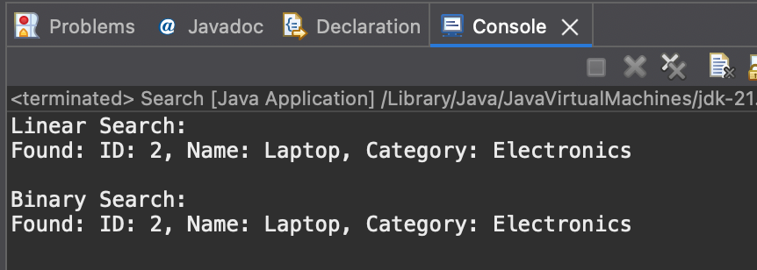

**Time Complexity Analysis:**

* Linear Search :
  + - Best Case - O(1)
    - Average / Worst Case - O(n)
* Binary Search :
  + - Best case - O(1)
    - Average / Worst Case - O(log n)

The main difference is that binary search requires sorting , where as linear search searches through all linearly.

**Best Approach for our problem :**

* Linear Search is suitable for a small list or when there are few no. of products.
* Binary Search is suitable for frequent searches on a large list.

**Exercise 7: Financial Forecasting**

**Scenario:**

You are developing a financial forecasting tool that predicts future values based on past data.

**Understanding Recursive Algorithms:**

Recursion is when a method calls **itself** to solve a smaller version of the same problem.

**But why use Recursion :?**It simplifies problems like :

Factorials

Fibonacci

Tree traversals

**CODE**

**FinancialForecast.java :**

public class FinancialForecast {

public static double predictValue(double initialValue, double rate, int years) {

if (years == 0) return initialValue;

return (1 + rate) * predictValue(initialValue, rate, years - 1);

}

public static void main(String[] args) {

double initialValue = 10000;

double annualGrowthRate = 0.1;

int years = 5;

double futureValue = predictValue(initialValue, annualGrowthRate, years);

System.out.printf("Predicted value after %d years: %.2f\n", years, futureValue);

}

}

**Output :**

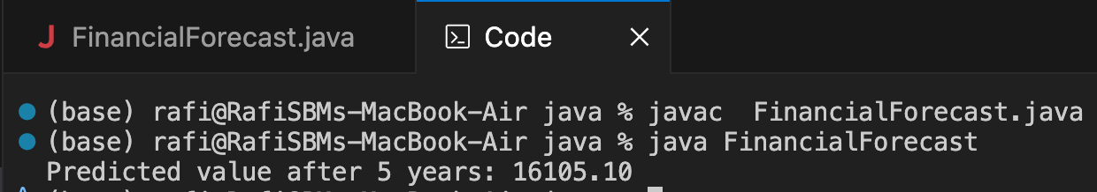

**Time Complexity Analysis:**

* T(n) = T(n-1) + O(1) --> O(n)

Linear time , but uses call stack memory

**Optimizing :**

Here the need of optimization is , cause recursion can:

* consume more memory -- stack overflow
* be slower than iterative solutions

can be optimized if we use iteration method , cause recursion takes O(n) for both space and time complexities , whereas iteration takes O(n) for time complexity and O(1) for space complexity ,leading to optimal speed.

**Exercise 3: Sorting Customer Orders**

**Scenario:**

You are tasked with sorting customer orders by their total price on an e-commerce platform. This helps in prioritizing high-value orders.

**Understand Sorting Algorithms:**

* **Bubble Sort -** It keeps swapping nearby numbers if they’re in the wrong order , again and again.
* **Insertion Sort -** It puts each number in the right place one by one like sorting plyaing cards
* **Quick Sort -** It picks a number , putts smaller ones on left , bigger on right,and repeats this.
* **Merge Sort -** It splits the list into halves, sorts them , and then joins them back together

**CODE**

**Order.java :**

package com.example.Sorting;

public class Order {

int orderId;

String customerName;

double totalPrice;

public Order(int orderId, String customerName, double totalPrice) {

this.orderId = orderId;

this.customerName = customerName;

this.totalPrice = totalPrice;

}

@Override

public String toString() {

return "Order ID: " + orderId + ",Customer: " + customerName + ", Total: ₹" + totalPrice;

}

}

**Sort.java :**

package com.example.Sorting;

public class Sort {

public static void bubbleSort(Order[] orders) {

int n = orders.length;

for (int i = 0; i < n - 1; i++) {

for (int j = 0; j < n - i - 1; j++) {

if (orders[j].totalPrice > orders[j + 1].totalPrice) {

Order temp = orders[j];

orders[j] = orders[j + 1];

orders[j + 1] = temp;

}

}

}

}

public static void quickSort(Order[] orders, int low, int high) {

if (low < high) {

int pi = *partition*(orders, low, high);

*quickSort*(orders, low, pi - 1);

*quickSort*(orders, pi + 1, high);

}

}

public static int partition(Order[] orders, int low, int high) {

double pivot = orders[high].totalPrice;

int i = low - 1;

for (int j = low; j < high; j++) {

if (orders[j].totalPrice < pivot) {

i++;

Order temp = orders[i];

orders[i] = orders[j];

orders[j] = temp;

}

}

Order temp = orders[i + 1];

orders[i + 1] = orders[high];

orders[high] = temp;

return i + 1;

}

public static void printOrders(Order[] orders) {

for (Order o : orders) {

System.***out***.println(o);

}

}

public static void main(String[] args) {

Order[] orders = {

new Order(301, "Ravi", 3000),

new Order(302, "Keerthi", 7000),

new Order(303, "Aarav", 4500),

new Order(304, "Riya", 2500),

new Order(305, "Rafi", 5000)

};

Order[] bubbleSorted = orders.clone();

Order[] quickSorted = orders.clone();

System.***out***.println("Original Orders:");

*printOrders*(orders);

*bubbleSort*(bubbleSorted);

System.***out***.println("\nAfter Bubble Sort:");

*printOrders*(bubbleSorted);

*quickSort*(quickSorted, 0, quickSorted.length - 1);

System.***out***.println("\nAfter Quick Sort:");

*printOrders*(quickSorted);

}

}

**Output :**

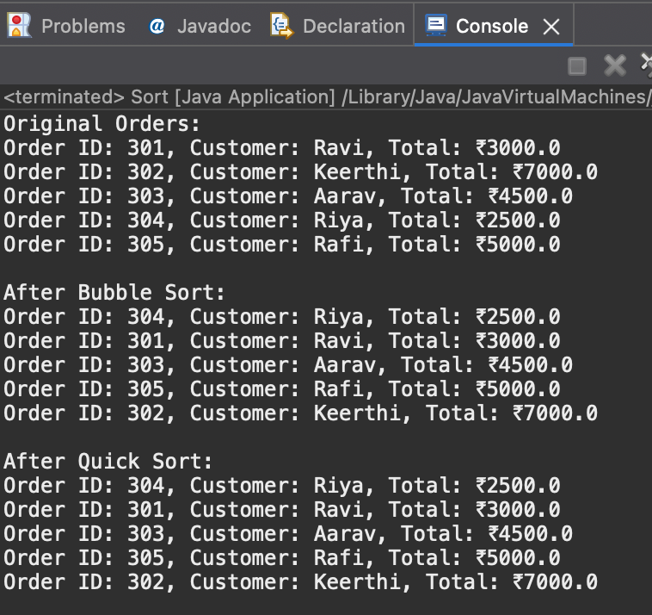

**Time Complexity Analysis:**

* **Bubble Sort -** Avg O() , its stable and has a sapce complexity of O(1)
* **Quick Sort -** Avg O(n log n) , it is not stable and has a space complexity of O(log n)

**Why Quick Sort is Prefered :**

* Much faster for larger inputs , used internally by Java’s Arrays.sort() for primitive types
* More efficient in real world cases

**Exercise 4: Employee Management System**

**Scenario:**

You are developing an employee management system for a company. Efficiently managing employee records is crucial.

**Understanding Array Representation:**

An array is a collection of elements stored at contiguous memory locations.

**ex :** int [] arr = {1,2,3} in memory looks looks like :

1. [2] [3]

0 1 2 <-- Indexes

**Advantages of Arrays :**

* Can be able to access any element in O(1) time using index
* We can loop thought it easily , uses a continuous block of memory

**CODE**

**Employee.java :**

package com.example.Arrays;

public class Employee {

int employeeId;

String name;

String position;

double salary;

public Employee(int employeeId, String name, String position, double salary) {

this.employeeId = employeeId;

this.name = name;

this.position = position;

this.salary = salary;

}

*@Override*

public String toString() {

return "ID: " + employeeId + ", Name: " + name + ", Position: " + position + ", Salary: " + salary;

}

}

**EmployeeSystem.java :**

package com.example.Arrays;

import java.util.Scanner;

public class EmployeeSystem {

static final int ***MAX_EMPLOYEES*** = 100;

static Employee[] *employees* = new Employee[***MAX_EMPLOYEES***];

static int *count* = 0;

public static void addEmployee(Employee e) {

if (*count* < ***MAX_EMPLOYEES***) {

*employees*[*count*++] = e;

System.***out***.println("Employee added.");

} else {

System.***out***.println("Employee limit reached.");

}

}

public static void searchEmployee(int id) {

for (int i = 0; i < *count*; i++) {

if (*employees*[i].employeeId == id) {

System.***out***.println("Found: " + *employees*[i]);

return;

}

}

System.***out***.println("Employee not found.");

}

public static void traverseEmployees() {

if (*count* == 0) {

System.***out***.println("No employees to display.");

return;

}

for (int i = 0; i < *count*; i++) {

System.***out***.println(*employees*[i]);

}

}

public static void deleteEmployee(int id) {

for (int i = 0; i < *count*; i++) {

if (*employees*[i].employeeId == id) {

for (int j = i; j < *count* - 1; j++) {

*employees*[j] = *employees*[j + 1]; // Shift left

}

*employees*[--*count*] = null;

System.***out***.println("Employee deleted.");

return;

}

}

System.***out***.println("Employee not found.");

}

public static void main(String[] args) {

Scanner sc = new Scanner(System.***in***);

int choice;

do {

System.***out***.println("\n1. Add Employee\n2. Search Employee\n3. View All Employees\n4. Delete Employee\n5. Exit");

System.***out***.print("Enter choice: ");

choice = sc.nextInt();

switch (choice) {

case 1:

System.***out***.print("Enter ID: ");

int id = sc.nextInt();

sc.nextLine();

System.***out***.print("Enter Name: ");

String name = sc.nextLine();

System.***out***.print("Enter Position: ");

String pos = sc.nextLine();

System.***out***.print("Enter Salary: ");

double sal = sc.nextDouble();

*addEmployee*(new Employee(id, name, pos, sal));

break;

case 2:

System.***out***.print("Enter ID to search: ");

int sid = sc.nextInt();

*searchEmployee*(sid);

break;

case 3:

*traverseEmployees*();

break;

case 4:

System.***out***.print("Enter ID to delete: ");

int did = sc.nextInt();

*deleteEmployee*(did);

break;

case 5:

System.***out***.println("Exiting...");

break;

default:

System.***out***.println("Invalid choice!");

}

} while (choice != 5);

sc.close();

}

}

**Output :**

**Adding an employee :**

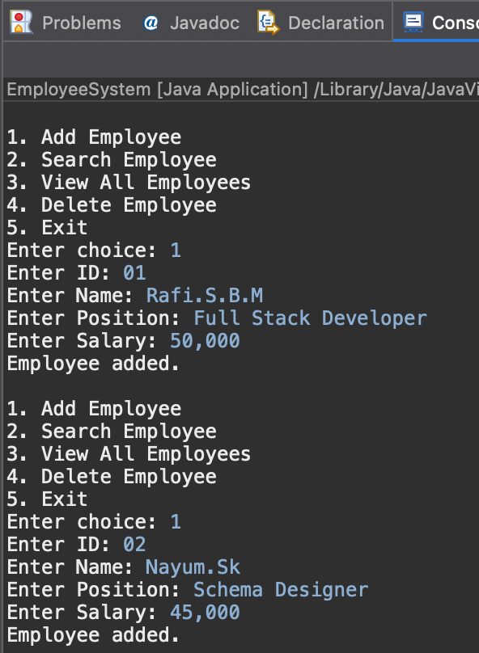

**Searching and Viewing employees** :

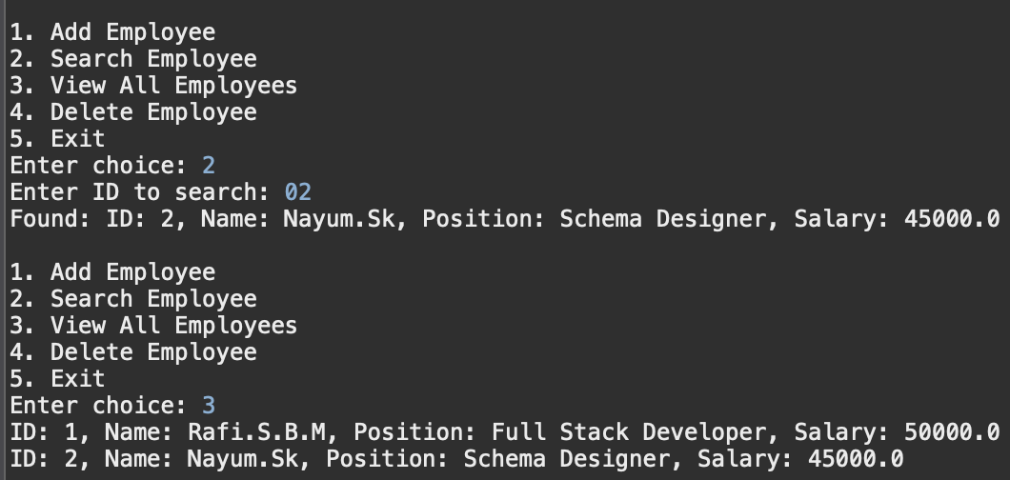

**Deleting an Employee :**

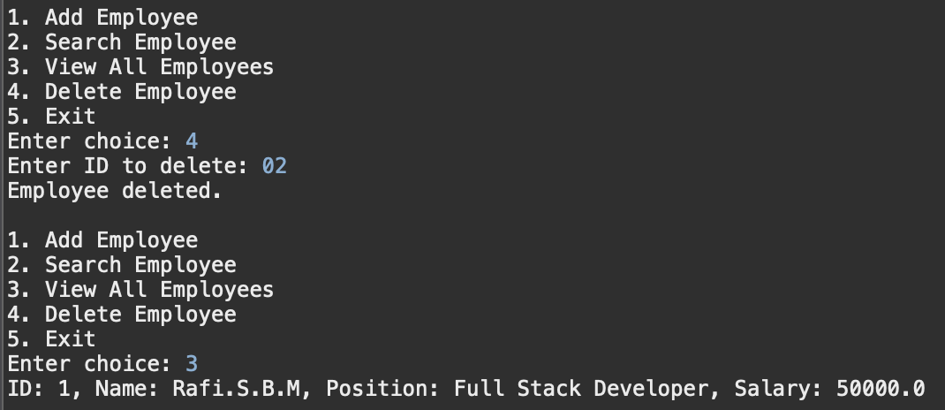

**Time Complexity Analysis:**

* Adding an element will take O(1) , Search and traversal,deleting of employees - O(n) ,

**Limitations of using Arrays:**

* **Fixed Size -** The size cannot increase beyond size (MAX_EMPLOYEES)
* Can’t esaily insert between elements
* **Costly delete operations ,** better alternations are ArrayList , HashMap for more flexibility.

**Exercise 5: Task Management System**

**Scenario:**

You are developing a task management system where tasks need to be added, deleted, and traversed efficiently.

**Understanding Linked Lists:**

* **Single Linked List :** Each item points to the next one only.
* **Doubly Linked List :** Each item points to both next and previous ones.

**CODE :**

**Task.java**

package com.example.Linked_List;

public class Task {

int taskId;

String taskName;

String status;

Task next;

public Task(int taskId, String taskName, String status) {

this.taskId = taskId;

this.taskName = taskName;

this.status = status;

this.next = null;

}

@Override

public String toString() {

return "ID: " + taskId + ", Name: " + taskName + ", Status: " + status;

}

}

**TaskLinkedList.java**

package com.example.Linked_List;

public class TaskLinkedList {

Task head;

public void addTask(int id, String name, String status) {

Task newTask = new Task(id, name, status);

if (head == null) {

head = newTask;

} else {

Task current = head;

while (current.next != null) {

current = current.next;

}

current.next = newTask;

}

System.***out***.println("Task added.");

}

public void searchTask(int id) {

Task current = head;

while (current != null) {

if (current.taskId == id) {

System.***out***.println("Found: " + current);

return;

}

current = current.next;

}

System.***out***.println("Task not found.");

}

public void traverseTasks() {

if (head == null) {

System.***out***.println("No tasks found.");

return;

}

Task current = head;

while (current != null) {

System.***out***.println(current);

current = current.next;

}

}

public void deleteTask(int id) {

if (head == null) {

System.***out***.println("No tasks to delete.");

return;

}

if (head.taskId == id) {

head = head.next;

System.***out***.println("Task deleted.");

return;

}

Task current = head;

while (current.next != null) {

if (current.next.taskId == id) {

current.next = current.next.next;

System.***out***.println("Task deleted.");

return;

}

current = current.next;

}

System.***out***.println("Task not found.");

}

}

**Main.java :**

package com.example.Linked_List;

import java.util.Scanner;

public class Main {

public static void main(String[] args) {

TaskLinkedList taskList = new TaskLinkedList();

Scanner sc = new Scanner(System.***in***);

int choice;

do {

System.***out***.println("\n1. Add Task\n2. Search Task\n3. View All Tasks\n4. Delete Task\n5. Exit");

System.***out***.print("Enter your choice: ");

choice = sc.nextInt();

switch (choice) {

case 1:

System.***out***.print("Task ID: ");

int id = sc.nextInt();

sc.nextLine();

System.***out***.print("Task Name: ");

String name = sc.nextLine();

System.***out***.print("Status: ");

String status = sc.nextLine();

taskList.addTask(id, name, status);

break;

case 2:

System.***out***.print("Enter Task ID to search: ");

int sid = sc.nextInt();

taskList.searchTask(sid);

break;

case 3:

taskList.traverseTasks();

break;

case 4:

System.***out***.print("Enter Task ID to delete: ");

int did = sc.nextInt();

taskList.deleteTask(did);

break;

case 5:

System.***out***.println("Exiting...");

break;

default:

System.***out***.println("Invalid choice!");

}

} while (choice != 5);

sc.close();

}

}

**Output :**

**Adding Tasks :**

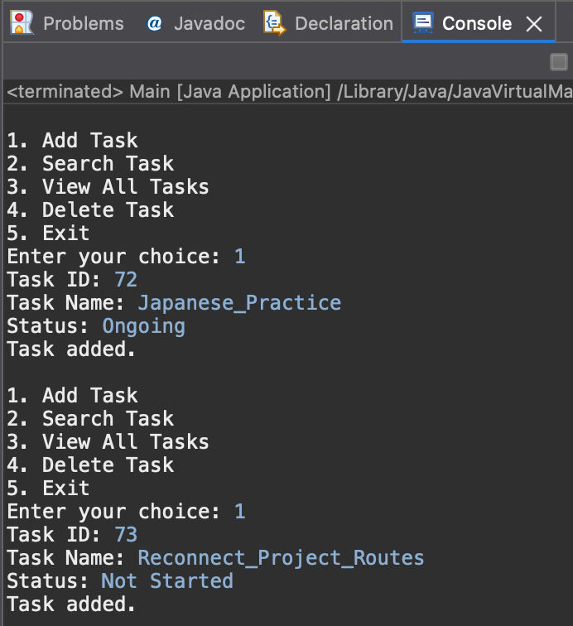

**Viewing Tasks :**

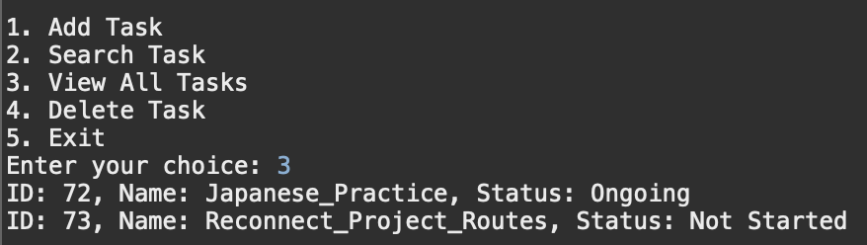

**Searching a task :**

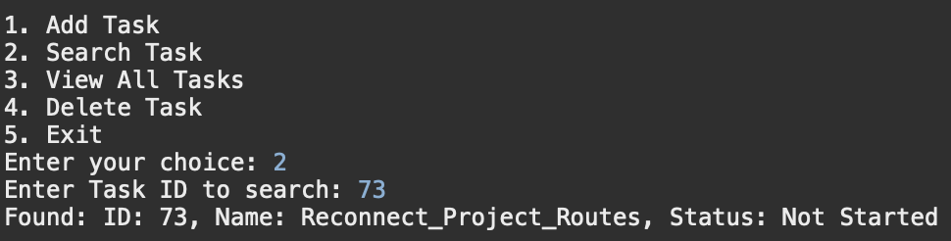

**Deleting a task :**

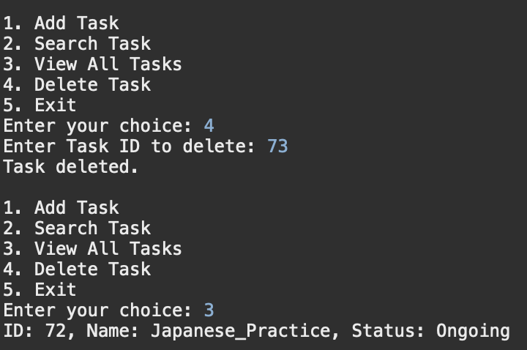

**Time Complexity Analysis:**

* Adding - at end , searching , traversal , deleting tasks - O(n)

**Advantages if Linked List over Array :**

* It can have dynamic Size which grows as per the need
* Easy Adjustment of pointers leading to felxible inseritons and deletions
* Memory is Scattered and not continuous

**Exercise 6: Library Management System**

**Scenario:**

You are developing a library management system where users can search for books by title or author.

**Understanding Search Algorithms:**

* **Linear Search -** Go one by one through the list to find the item, works on unsorted data.
* **Binary Search -** Keep cutting the sorted list in half to find the item faster, only works on sorted data.

**CODE**

**Book.java :**

package com.example.Search;

public class Book {

int bookId;

String title;

String author;

public Book(int bookId, String title, String author) {

this.bookId = bookId;

this.title = title;

this.author = author;

}

@Override

public String toString() {

return "Book ID: " + bookId + ", Title: \"" + title + "\", Author: " + author;

}

}

**LibrarySearch.java :**

package com.example.Search;

import java.util.Arrays;

import java.util.Comparator;

public class LibrarySearch {

// Linear Search by title

public static int linearSearch(Book[] books, String title) {

for (int i = 0; i < books.length; i++) {

if (books[i].title.equalsIgnoreCase(title)) {

return i;

}

}

return -1;

}

public static int binarySearch(Book[] books, String title) {

int left = 0, right = books.length - 1;

while (left <= right) {

int mid = (left + right) / 2;

int cmp = title.compareToIgnoreCase(books[mid].title);

if (cmp == 0) return mid;

else if (cmp < 0) right = mid - 1;

else left = mid + 1;

}

return -1;

}

public static void printBooks(Book[] books) {

for (Book b : books) {

System.***out***.println(b);

}

}

public static void main(String[] args) {

Book[] books = {

new Book(301, "The Alchemist", "Paulo Coelho"),

new Book(302, "1984", "George Orwell"),

new Book(303, "To Kill a Mockingbird", "Harper Lee"),

new Book(304, "Atomic Habits", "James Clear"),

new Book(305, "The Great Gatsby", "F. Scott Fitzgerald")

};

String searchTitle = "To Kill a Mockingbird";

int linearIndex = *linearSearch*(books, searchTitle);

System.***out***.println("Linear Search result:");

if (linearIndex != -1) {

System.***out***.println(books[linearIndex]);

} else {

System.***out***.println("Book not found.");

}

Arrays.*sort*(books, Comparator.*comparing*(b -> b.title.toLowerCase()));

int binaryIndex = *binarySearch*(books, searchTitle);

System.***out***.println("\nBinary Search Result:");

if (binaryIndex != -1) {

System.***out***.println(books[binaryIndex]);

} else {

System.***out***.println("Book not found.");

}

}

}

**Output :**

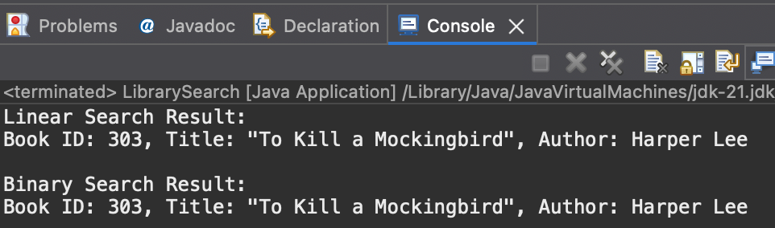

**Time Complexity Analysis:**

* **Best case -** Both Linear Search , Binary Search has O(1)
* **Avg/Worst case** 
  + - * Liner Search O(n);
      * Binary Search O(log n);

**When to use which one ?**

* If data is unsorted then go with Linear Search , if its sorted then go with Binary Search.
* Use Binary Search (with sorting beforehand) if there are large data sets and performance is needed

**Exercise 1: Inventory Management System**

**Scenario:**

You are developing an inventory management system for a warehouse. Efficient data storage and retrieval are crucial.

**Why are Data Structures and Algorithms important ?**

* In a large warehouse , there might be having thousands of items.
* If we don’t use proper data structure , searching or updating a product can become very slow.
* So , to make the system fast and efficient, we need to pick the right data structure.

**Suitable Data Structures for this problem are :**

1. **ArrayList** - Which is simple and keeps insertion order ; is best if we mostly add/display products.
2. **HashMap** - Fast O(1) access via key ; best for quick searching,updating,deleting using product ID which is the best option for this problem.

**CODE**

**product.java :**

package com.example.inventory;

public class Product {

int productId;

String productName;

int quantity;

double price;

public Product(int productId, String productName, int quantity, double price) {

this.productId = productId;

this.productName = productName;

this.quantity = quantity;

this.price = price;

}

*@Override*

public String toString() {

return "ID: " + productId + ", Name: " + productName + ", Quantity: " + quantity + ", Price: ₹" + price;

}

}

**InventoryManager.java :**

package com.example.inventory;

import java.util.HashMap;

import java.util.Scanner;

public class InventoryManager {

static HashMap<Integer, Product> *inventory* = new HashMap<>();

public static void addProduct(int id, String name, int quantity, double price) {

if (*inventory*.containsKey(id)) {

System.***out***.println("Product already exists with ID: " + id);

} else {

Product p = new Product(id, name, quantity, price);

*inventory*.put(id, p);

System.***out***.println("Product added.");

}

}

public static void updateProduct(int id, int quantity, double price) {

if (*inventory*.containsKey(id)) {

Product p = *inventory*.get(id);

p.quantity = quantity;

p.price = price;

System.***out***.println("Product updated.");

} else {

System.***out***.println("Product not found!");

}

}

public static void deleteProduct(int id) {

if (*inventory*.containsKey(id)) {

*inventory*.remove(id);

System.***out***.println("Product deleted.");

} else {

System.***out***.println("Product not found!");

}

}

public static void viewInventory() {

if (*inventory*.isEmpty()) {

System.***out***.println("Inventory is empty.");

} else {

for (Product p : *inventory*.values()) {

System.***out***.println(p);

}

}

}

public static void main(String[] args) {

Scanner sc = new Scanner(System.***in***);

int choice;

do {

System.***out***.println("\n1. Add Product\n2. Update Product\n3. Delete Product\n4. View Inventory\n5. Exit");

System.***out***.print("Enter your choice: ");

choice = sc.nextInt();

switch (choice) {

case 1:

System.***out***.print("Product ID: ");

int id = sc.nextInt();

sc.nextLine();

System.***out***.print("Name: ");

String name = sc.nextLine();

System.***out***.print("Quantity: ");

int qty = sc.nextInt();

System.***out***.print("Price: ");

double price = sc.nextDouble();

*addProduct*(id, name, qty, price);

break;

case 2:

System.***out***.print("Product ID to update: ");

int uid = sc.nextInt();

System.***out***.print("New Quantity: ");

int uq = sc.nextInt();

System.***out***.print("New Price: ");

double up = sc.nextDouble();

*updateProduct*(uid, uq, up);

break;

case 3:

System.***out***.print("Product ID to delete: ");

int did = sc.nextInt();

*deleteProduct*(did);

break;

case 4:

*viewInventory*();

break;

case 5:

System.***out***.println("Exiting...");

break;

default:

System.***out***.println("Invalid choice");

}

} while (choice != 5);

sc.close();

}

}

**Output :**

**Adding a Product :**

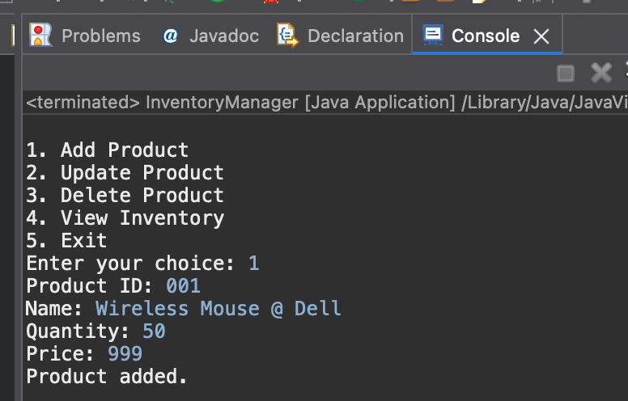

**Viewing Inventory :**

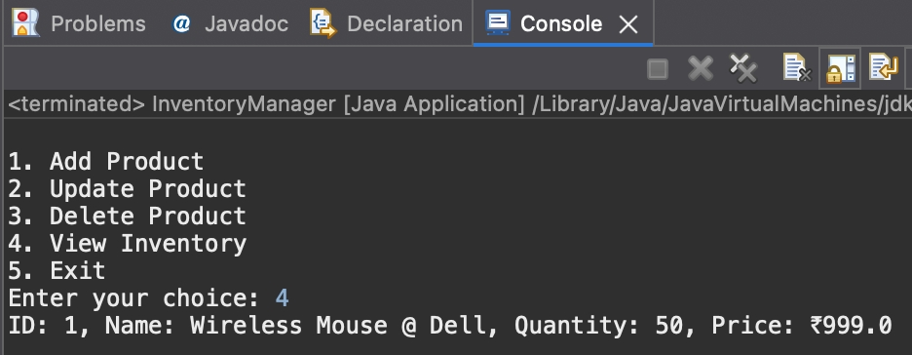

**Updating Product data :**

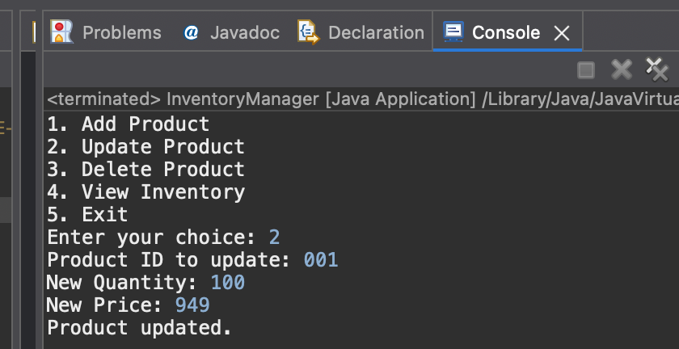

**Updated Inventory details :**

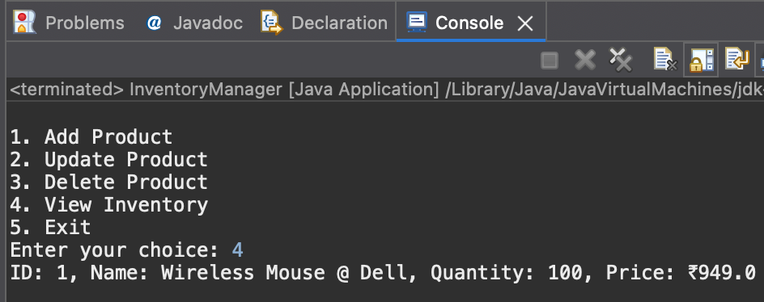

**Deleting a product & Viewing the inventory :**

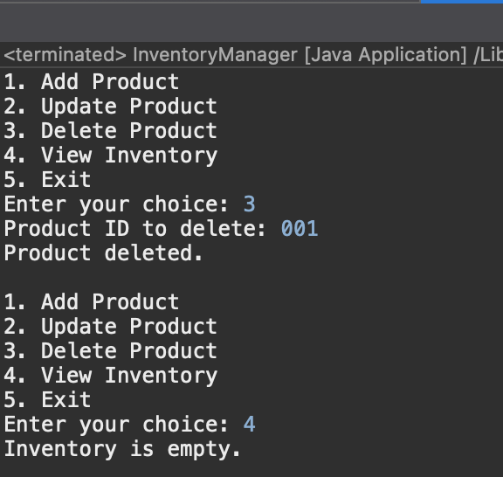

**Time Complexity Analysis:**

* Add Product , Update Product , Delete Product - takes O(1) time complexity, whereas viewing all of them will take O(n) .
* HashMap is already optimal for ID - based access , To sort/view based on name/price,convert inventory.values() to a list and sort using Collections.sort() with a custom comparator.